developer GUide

# Introduction

I’ve created a windows store app on News Stand. Where user can know news all over the world. He can run with time, what’s going around world and him. I’ve made many sections about news, I included global news, national news, sports news, weather forecast, health news, education news, entertainment news, science news & some facts about Pakistan. I’ve used RSS feeds for news .This is developer guide so I mention it also that I used app bar for navigation, search pane for search different pages and some blend also.

index

1. Global News
2. National News
3. Sports News
4. Weather News
5. Health News
6. Education News
7. Entertainment News
8. Facts
9. RSS Page
10. App Bar
11. Search Pane
12. Blend
13. Sources

global news

In global news I used grids for displaying different region images and names. I used 3 grids in this section, one is for world latest news as a main grid, 2nd one is made below the 1st grid & 3rd one is on the right of 1st grid which contains many more news. Each of them consist of RSS links which will navigate to RSS page when user click on any one where RSS will appear & after click on it, news will appear on right side in web view. I used **‘load’** event on grids, grids will appear when page open, **‘SelectionChanged ‘**event on grid, when user click on it then RSS will appear & **‘PointerPressed’** event of page for searching pages. App bar is used for navigation from current page to other and exit from app.

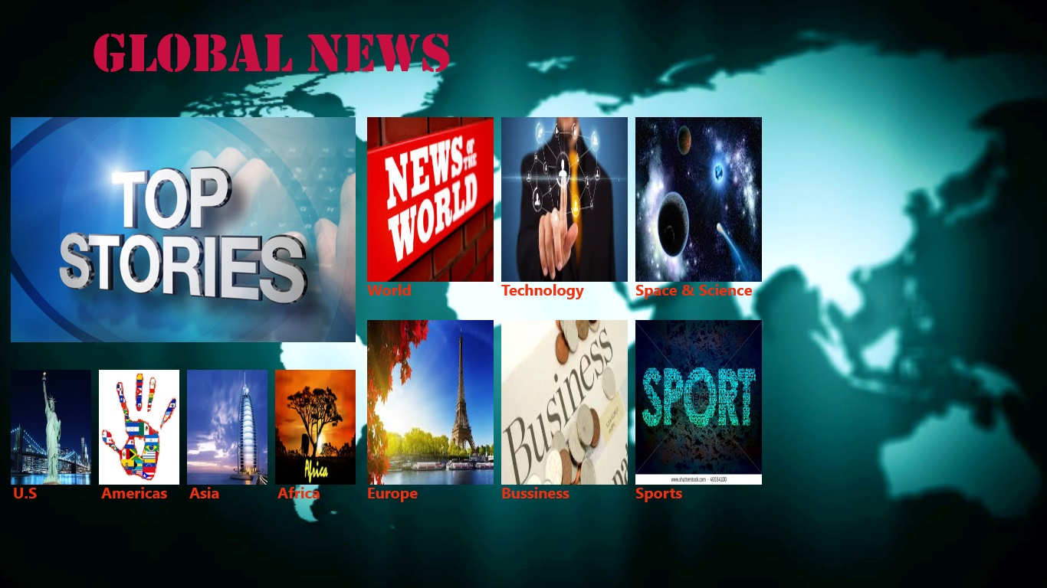

national news

In national news I used grids for displaying different countries images and names. I used 3 grids in this section, one is for Pakistan’s latest news as a main grid, 2nd one is made below the 1st grid & 3rd one is on the right of 1st grid which contain different countries. Each of them consist of RSS links which will navigate to RSS page when user click on any one, then RSS will appear & after click on it ,news will appear on right side in web view. . I used **‘load’** event on grids, grids will appear when page open, **‘SelectionChanged ‘**event on grid, when user click on it then RSS will appear & **‘PointerPressed’** event page for searching pages. App bar is used for navigation from current page to other and exit from app.

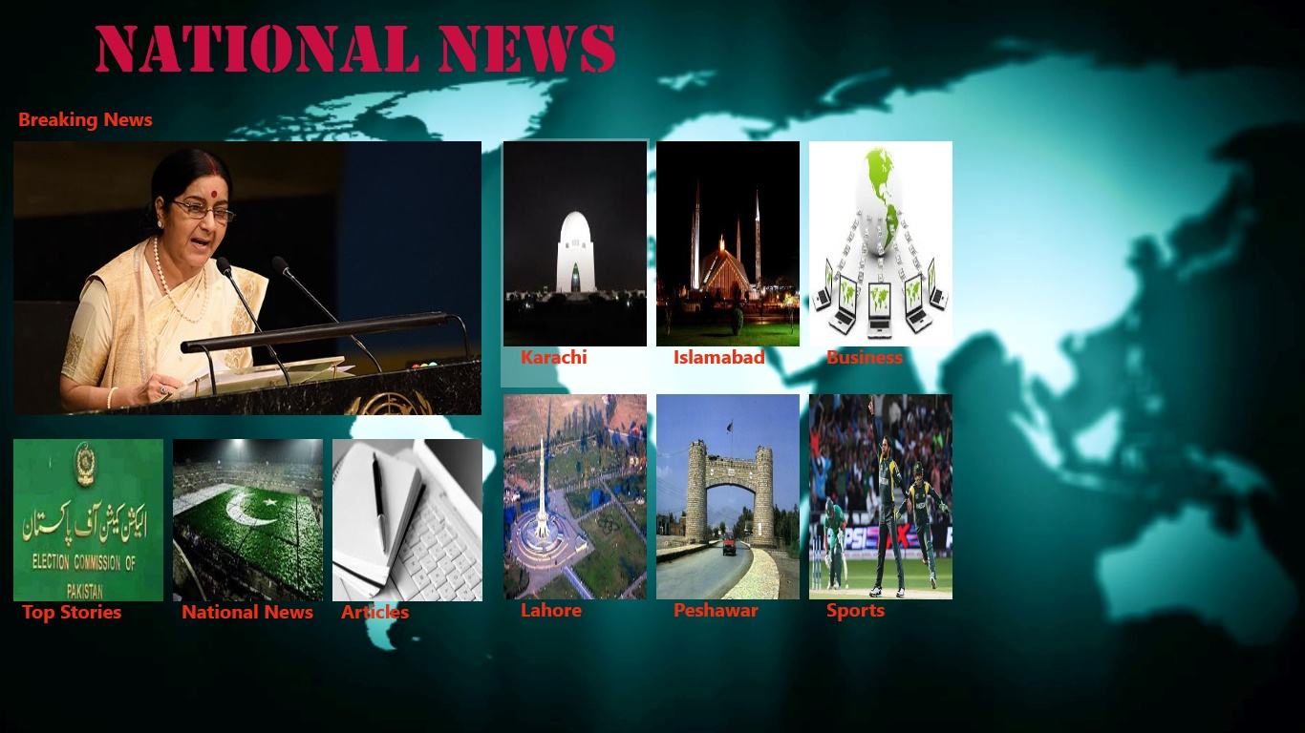

SPORTS news

In sports news I used single grid for displaying different sports images and names. I used grid in this section in which latest news of different sports are available. Each of them consist of RSS links which will navigate to RSS page when user click on any one, then RSS will appear & after click on it, news will appear on right side in web view. I used **‘load’** event on grids, grids will appear when page open, **‘SelectionChanged ‘**event on grid, when user click on it then RSS will appear & **‘PointerPressed’** event of page for searching pages. App bar is used for navigation from current page to other and exit from app.



Health news

In health news I used single grid for displaying health news images and names. I used grid in this section in which latest news of health are available. Each of them consist of RSS links which will navigate to RSS page when user click on any one, then RSS will appear & after click on it, news will appear on right side in web view. I used **‘load’** event on grids, grids will appear when page open, **‘SelectionChanged ‘**event on grid, when user click on it then RSS will appear & **‘PointerPressed’** event of page for searching pages. App bar is used for navigation from current page to other and exit from app.



weather news

In weather news I used web services. In this user will enter country name via button click which search cities of that country by tag name of xml source. I used **‘SelectionChanged ‘**event on combo box, when user click on it then it will show cities of that country via tag name of xml source file of web service ,when click on any city the temperature will appear in a text block. **‘PointerPressed’** event of page for searching pages. App bar is used for navigation from current page to other and exit from app.

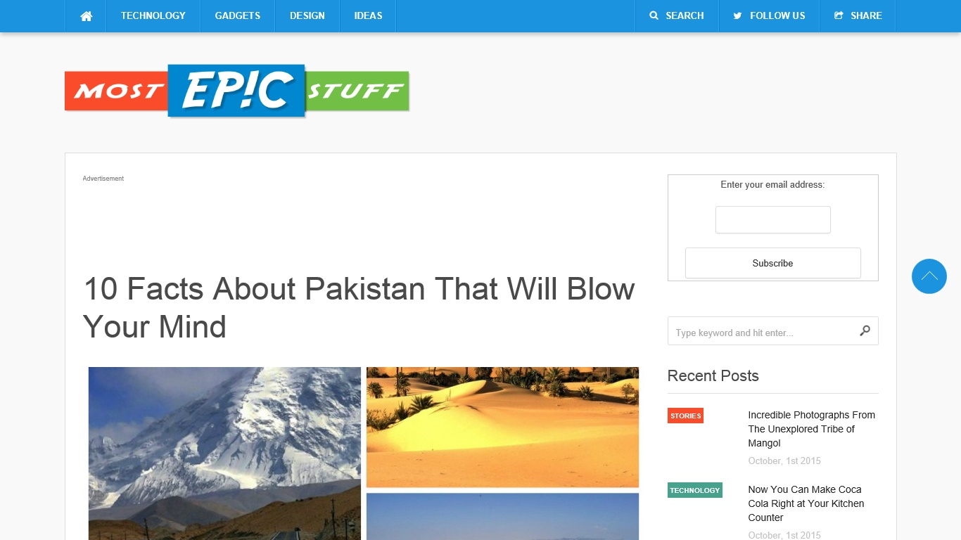

Education news

In education I just give URI link of RSS feed on it, this link navigate to RSS page, on which web view will display content. App bar is used for navigation from current page to other and exit from app.



Entertainment news

In entertainment news I used a grid and 3 listview for displaying Bollywood, Hollywood and fashion news images and names. Each of them consist of RSS links which will navigate to RSS page when user click on any one, then RSS will appear & after click on it, news will appear on right side in web view. I used **‘load’** event on each list view, list will appear when page open, **‘SelectionChanged ‘**event on each list view, when user click on it then RSS will appear & **‘PointerPressed’** event of page for searching pages. App bar is used for navigation from current page to other and exit from app.

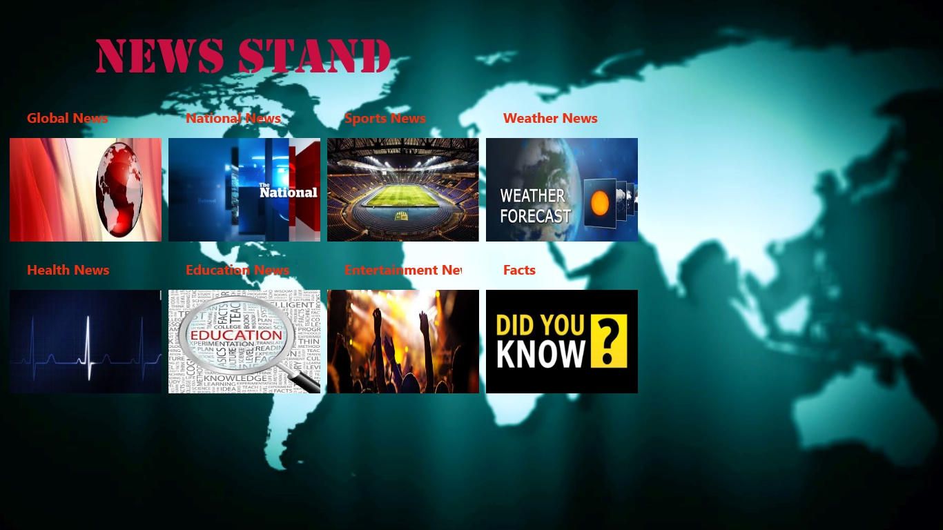

Facts

I did it like education news but it will appear on other page on web view which will accept URI link. App bar is used for navigation from current page to other and exit from app.



rss page

In which I used RSS of different sources. Feed item class is made which accept content, title, publication date and link of RSS in **‘load’** event of page. **‘SelectionChanged’** event cause appear of news on right side in web view which accept link of RSS. Message dialog box is also used for different condition.

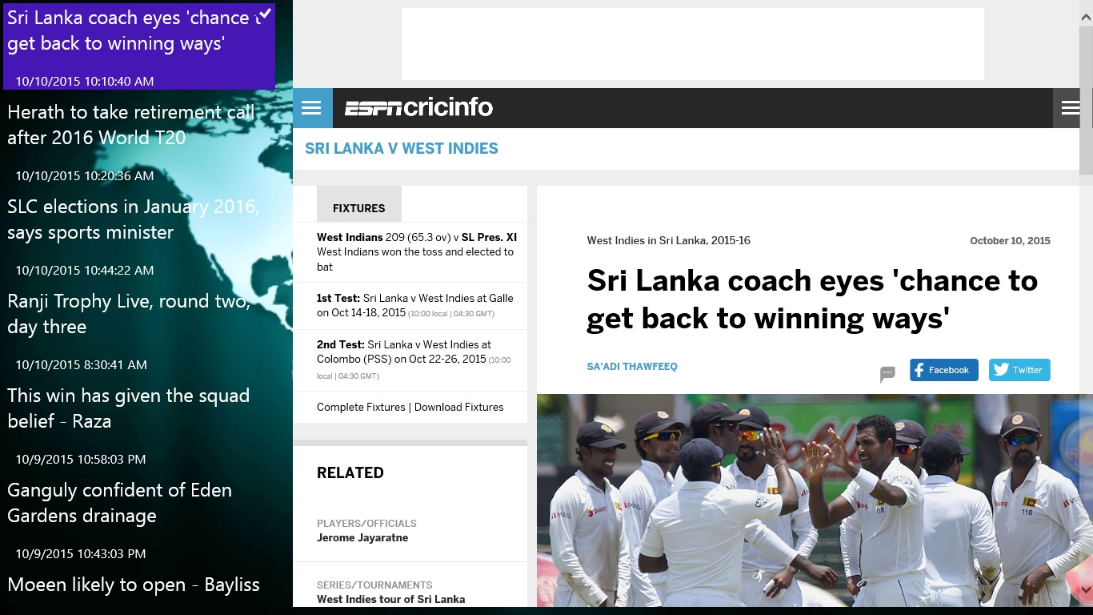

APP BAR

Top app bar is used in all pages except page of facts, in which bottom app bar is used. App bar is used for navigation and can terminate app via app bar.

Blend

I used blend storyboard in app. It is used in pages & in the start of app. In start of app blend is used for moving image from left & on pages I used opacity low to high.

Sources

* CNN
* BBC
* ESPN
* THE NEW YORK TIMES
* THE NEWS
* BOLLYWOOD HUNGAMA
* GURDIANS
* TIMES OF INDIA
* ARAB NEWS
* GULF NEWS.COM
* GLAMOUR.COM
* FASHION TRENDS.COM
* CINEMABLEND.COM
* http://www.ei-ie.org/rss